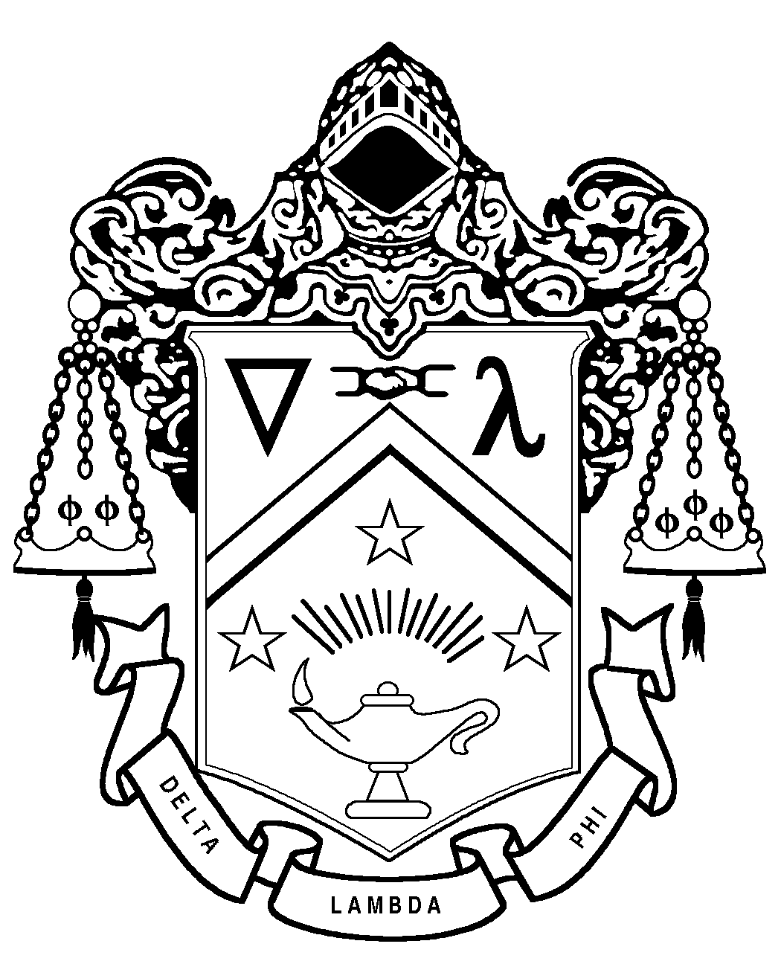

Delta Lambda Phi
Risk Management Policy (RMP) Incident Report Form

All potential or alleged RM violations must be reported within 24 hours.
Send the completed form as an attachment to riskmanagement@dlp.org

Name of Reporting Member:

Chapter/Colony:

Position:

Date of Report:

Date of Alleged Violation(s):

Time(s) of Alleged Violation(s):

Location(s) of Alleged Violations(s):

Did you witness the incident? If not, how and when did you become aware of the Alleged Violation(s)?

Did the Alleged Violation occur during an officially sponsored or sanctioned event?

If Yes, what type of event was it?

If No, what do you believe may make this a violation of the Fraternity’s Risk Management Policy?

Who allegedly violated the RMP? [Provide name(s), chapter/colony, status, and office held, if any]:

Who may have witnessed the Alleged Violation? [Provide name(s), chapter/colony, status, and office held, if any]:

Who else may have information regarding the Alleged Violation? [Provide name(s), chapter/colony, status, and office held, if any]:

What actions, if any, have already been taken by the chapter/colony or others to address the Alleged Violation?

Has the Chapter/Colony Advisor/Mentor been made aware of the Alleged Violation?

For campus or multi-campus based chapter/colonies: If Alleged Violation also violates campus policies, has a college/university staff member been made aware of the situation? If so, provide name and contact information for the staff member.

Please provide a detailed summary of the Alleged Violation, including information about the conduct of the persons involved, affiliations of the individuals involved, injuries sustained, ages of the persons involved if known, etc. Use as many pages as necessary.

Submitted by:

Name Position

Phone Number Email

Signature Date

